OFFICIAL COORDINATION REQUEST FOR
NON-ROUTINE OPERATIONS AND MAINTENANCE

COORDINATION TITLE- 20JDA12 MOC Spill bay 2 attraction flow
COORDINATION DATE- 03 August 2020
PROJECT- John Day Dam
RESPONSE DATE- 13 August 2020

Description of the problem-

The current spill plan for JD from 15-31 August is for 20kcfs 24 hrs/day. The spill pattern during this time frame calls for TSW flow per the FPP spill pattern, which leaves no spill on the North end of the spillway near the North fish ladder entrance. JD fisheries requests 1 stop (1.6Kcfs) out of spill bay 2 for better attraction to the entrance of the North ladder.

Spill bay 2 is used at one stop from 1 Sept – 30 November for attraction flow to the North ladder per the FPP.

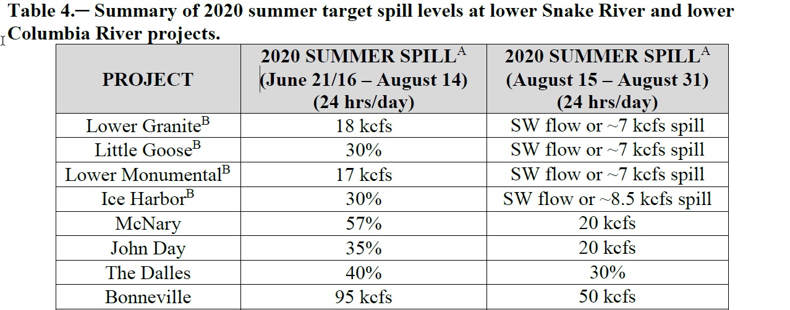

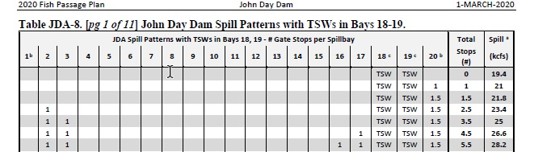

Type of outage required

Additional spill is requested from spillbay 2 of one stop.

Impact on facility operation
Spill pattern would change. No change to ladder operations.
Impact on unit priority
None
Impact on forebay/tailwater operation
None
Impact on spill
Increased spill of 1.6kcfs at one stop from spillbay 2.

Dates of impacts/repairs

15 – 31 August

Length of time for repairs

N/A

Analysis of potential impacts to fish

- 10-year average passage by run of the predominate species during the period of deviation to spill for adults and juvenile listed species, as appropriate for the proposed action and time of year

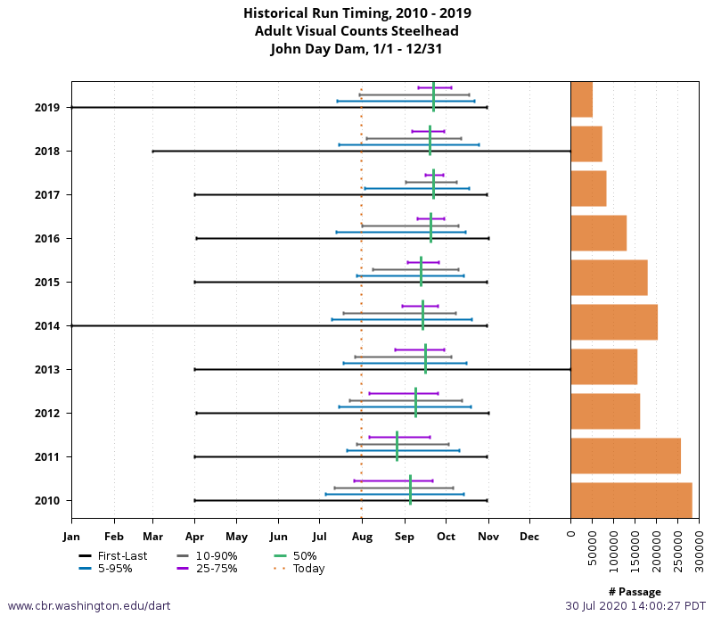
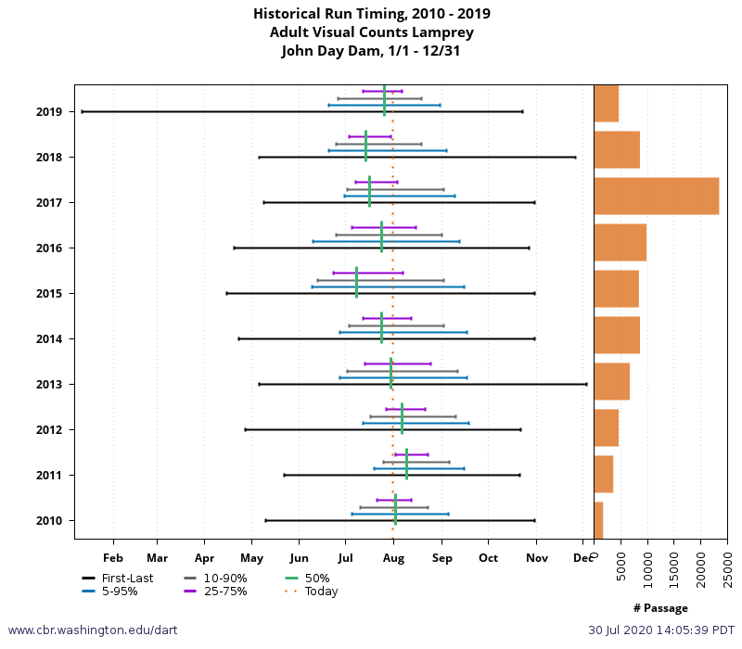

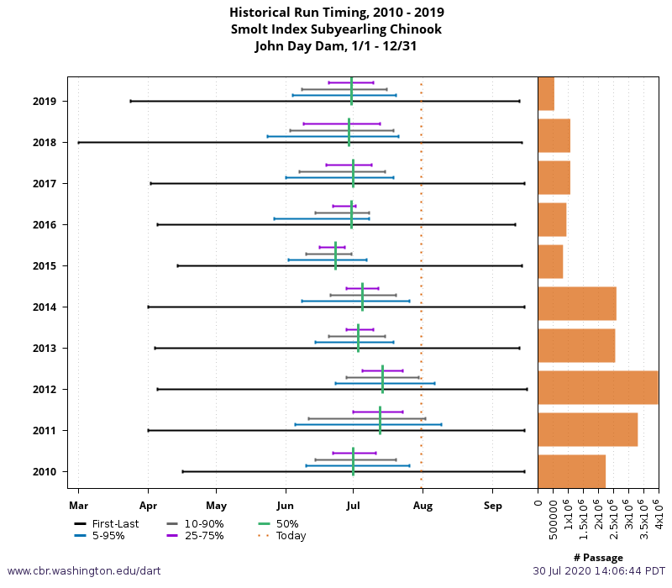

- Chinook, steelhead, and sockeye are all near the 10 year average and lamprey are passing below the 10 year average.

- Sub-yearling Chinook salmon will not be affected by this action and would benefit by an additional passage route besides the TSW’s. Adult salmonids and Lamprey will benefit from the added attraction flow to the North ladder.

Summary statement - expected impacts on:

Downstream migrants

Minimal impact from this deviation to spill is expected to downstream migrants.

Upstream migrants (including Bull Trout)

Increased attraction flow will benefit upstream migrants at the North fish ladder.

Lamprey

Same as above

Comments from agencies
BPA
-----Original Message-----
From: Bettin,Scott W (BPA) - EWP-4 [mailto:swbettin@bpa.gov]
Sent: Monday, August 03, 2020 12:43 PM
To: Kovalchuk, Erin H CIV USARMY CENWP (USA) <Erin.H.Kovalchuk@usace.army.mil>
Subject: [Non-DoD Source] RE: FPOM: Official Coordination 20JDA12 MOC Spill Bay 2 attraction flow

If we ran without the attraction spill from bay 2 how long would it be to know if we are having an issue? I was thinking implement the FOP and react once we see an issue? -s

Final coordination results

After Action update (After action statement stating what the effect of the action was on listed species. This statement could simply state that the MOC analysis was correct and the action went as expected, or it could explain how the actual action changed the expected effect (e.g., you didn’t need to close that AWS valve after all, so there was no impact of the action). List any actual mortality noted as a result of the action)

Please email or call with questions or concerns.
Thank you,
Erin

Erin Kovalchuk
NWP Operations Division Fishery Section
Columbia River Coordination Biologist
Erin.H.Kovalchuk@usace.army.mil

And

Eric Grosvenor
Fish Biologist
John Day Dam
Eric.G.Grosvenor@usace.army.mil

